# DAR-OTR Alert

Note: The below screenshot is just to show where the different data is located on the screen:

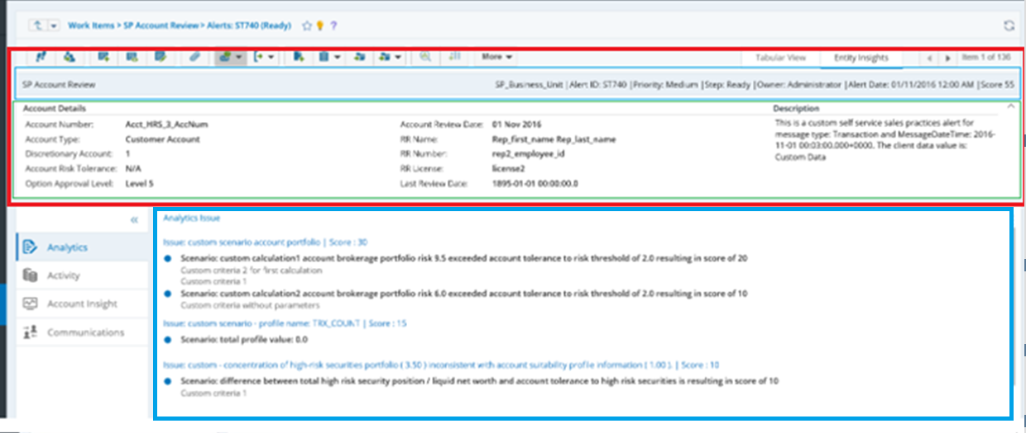

## Top Banner Collapsed:

|  |
| --- |
| SP Account Review SP Business Unit | Alert ID : RTS-OTR-101637835 | Priority: High |Step: Ready |Owner: Administrator | Alert Date: 11/13/2021 |Score: 50 |

## Top Banner Expanded (Red Box)

|  |  |  |  |  |  |  |  |  |
| --- | --- | --- | --- | --- | --- | --- | --- | --- |
| **Account Name** | Something LTD |  | **Account Number** | 41143854 |  | **Primary Party Age** | 49 | **Description**  Account has option trades that appear to brake the Minimum Standards of Account Supervision rule(s) |
| **Option Approval Level** | 3 |  | **IA Code** | JKV |  | **IA Name** | Peter Smith |
| **Branch Cd** | 411 |  | **Branch Name** | North York |  | **Fee Type** | Comm (regular) |
| **Discretionary** | No |  | **Registered** | No |  | **Account Category** | Customer Account |
| **KYC Client Risk Low/Medium/Med-High/High** | 0/100/0/0 |  | **KYC Time Horizon <1/1-3/3-5/5-10/10+** | 0/0/0/0/100 |  | **KYC Investment Objectives: Cap. Preservation/Income/Growth/ Aggressive Growth** | 20/30/50/0 |

Question: Do you want the KYC row for this Rule?

## Analytics (Blue Box):

**On 2015-09-25 the account has trades that appear to break the following Minimum Standards of Account Supervision rules:**

Violated **-** Rule 1 – No Option Trading Approved

Violated **-** Rule 2 – Long Options Trading Not Approved

Violated **-** Rule 3 – Option Spreads Not Approved

Violated **-** Rule 4 –  Naked Puts Not Approved

Violated - Rule 5 –  Naked Calls Not Approved

Violated - Rule 6 –  Trades Not Approved for Registered Accounts

Violated - Rule 7 –  Close of Covering Put for Option Position

Violated **-** Rule 7 –  Close of Covering Call for Option Position

Violated **-** Rule 8 –  Large Option Trade, $1150 (Threshold = $1000)

Account Approval - level 4 – Naked Put Options Trading

**Rules Violated | Score 20**

Number of Rules Violated 2, Score is 20

**Trades Violating the Rule | Score 20**

Number of Trades Violating the Rules 2, Score is 20

**Prior Alerts by Account | Score 10**

Number of Prior OTR Alerts for the account in the prior 6 months 2, Score is 10

**Notes**:

Only Rules that are Violated will appear in the solution above, so the list will be much shorter.

The account approval level is the only row that will always be displayed, and Level 4 above, is just an example.

Green values are those calculated/based on threshold

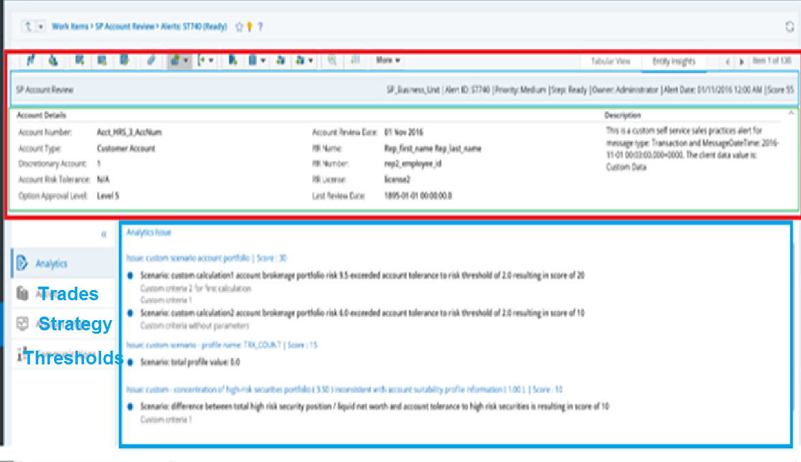

## Custom **Trades** Preset



## Custom **Strategy** Preset

Option1 (Amit suggested after the call)

|  |  |  |  |  |  |  |  |  |  |
| --- | --- | --- | --- | --- | --- | --- | --- | --- | --- |
| **Date** | **Total Short Call Contracts** | **Total Long Call Contracts** | **Total Long Shares** | **Shortfall Quantity** | **Underlying Description** | **Total Short Put Contracts** | **Total Long Put Contracts** | **Total Short Shares** | **Shortfall Quantity** |
| 2015/09/25 | 0 | 0 | 30,000 | 0 | National Bank Of Canada | 50 | 0 | 0 | 5,000 |
| 2021/01/23 | 0 | 0 | 0 | 0 | Toronto-Dominion Bank | 50 | 0 | 0 | 5,000 |

Or Option 2 (the option from the call)

|  |  |  |  |  |  |  |  |  |  |
| --- | --- | --- | --- | --- | --- | --- | --- | --- | --- |
| **Underlying Description** | **Date** | **Total Short Call Contracts Held** | **Total Long Call Contracts** | **Total Long Shares** | **Shortfall Quantity** | **Total Short Put Contracts Held** | **Total Long Put Contracts** | **Total Short Shares** | **Shortfall Quantity** |
| National Bank Of Canada | 2015/09/25 | 0 | 0 | 30,000 | 0 | 50 | 0 | 0 | 5,000 |
| Toronto-Dominion Bank | 2021/01/23 | 1,200 | 330 | 40,000 | 50,000 | 150 | 90 | 10,000 | 0 |

1. Please choose one option.
2. I have 2 versions of the titles for the above table. Please let me know if you want to see the words above in red (Held, Contract) in the title or not

## **Thresholds**

Trade Min Size (Contracts) 1

## **Previous OTR Alerts in Lookback for the Account**